**Business Analyst Solved Case Study**

**Solved by – Karthik Vuppula**

Athlete360 – a complete view of athlete health and performance

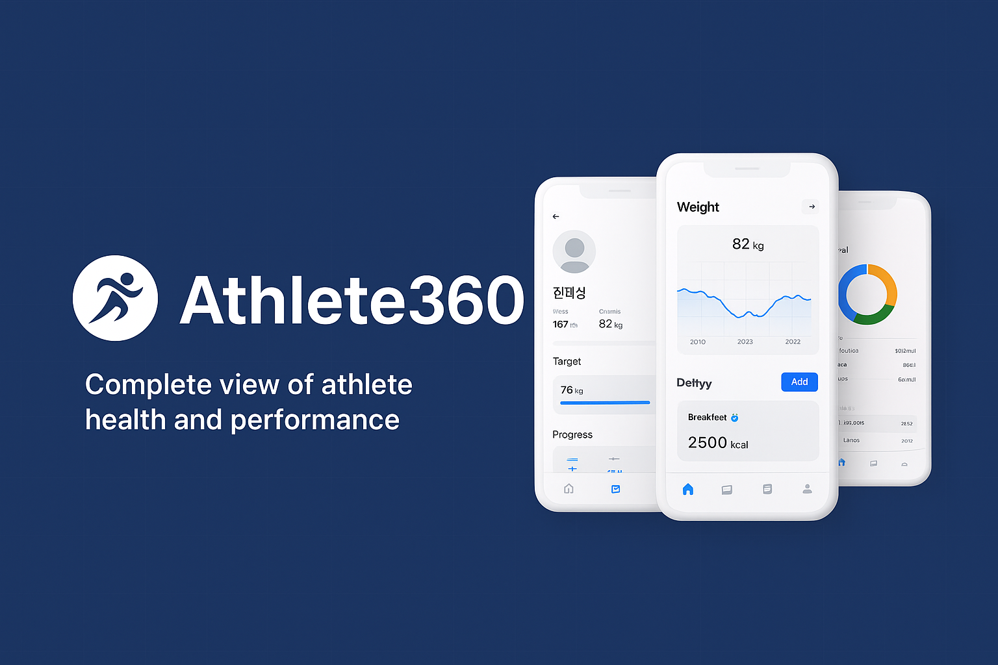

The experienced development team is taking on a new project – creating a health monitoring application that will allow athletes and their coaches to track various aspects of their health.   
  
The business is in Korea and targets only the Korean market.   
Initial target market professional – Professional Ice hockey players, 20-30 age. Athletes spend all day training and doing nothing else. Every athlete has a professional vital tracking device with access to the internet. Coaches use pads to track progress.

Athletes will be able to.

* track the meals they eat,
* their water consumption
* their physical activity,
* their goals, and
* their weight

Coaches will be able to view the information that their athletes enter.

The user will enter personal information such as:

* Height
* Current weight, and
* Target weight

**Question 1:**Identify at least 10 dependencies and thn generate a release plan with four sprints based on the prioritized release backlog. You may place any unassigned user stories in a backlog.   
  
**Answer 1:**   
Dependencies:   
1) Availability of vital tracking devices and internet connectivity for athletes.   
2) Availability of pads or other devices for coaches to track progress.  
3) Integration with existing health tracking platforms or devices.  
4) Compliance with data privacy and security regulations.   
5) Database design and setup for storing user information, data, and progress.   
6) Availability of development resources and expertise.   
7) Availability of funding and resources to support the project.   
8) Access to relevant health and fitness data and research.   
9) Availability of technical support and maintenance for the application.  
10) Collaboration and communication between athletes, coaches, and development team.

**Release Plan with four sprints:   
  
SPRINT 1: Basic User Functionality**

* User Story 1: Enter weight and Height information (3 points)
* User Story 2: Track Weight Improvements (5 points)
* User Story 3: Set Target Weight (1 point)
* User Story 15: Enter Fitness Goals (2 points)
* User Story 16: Enter Dietary Goals (2 points)
* User Story 20: Coach Visibility of Height and Weight (5 points)
* User Story 21: Coach and Visibility of Exercise (5 points)
* User Story 22: Coach and Visibility of Diet (5 points)

**Sprint 2: Tracking and Notifications**

* User Story 5: Enter Exercise Tracking (5 points)
* User Story 12: Enter Water consumption tracking (3 points)
* User Story 4: Calculate weekly weight loss (2 points)
* User Story 9: Enter Calories for Food (2 points)
* User Story 19: Link Coach to Account (8 points)
* User Story 24: Coach Visibility of Fitness Goals (3 points)
* User Story 25: Coach Visibility of Dietary Goals (3 points)

**Sprint 3: Goals and Recommendations**

* User Story 6: Calculate Calories Burned in Workout (5 points)
* User Story 13: Suggested water consumption Calculation (2 points)
* User Story 11: Notify if Not meeting Calorie Intake (2 points)
* User Story 17: Notify if not meeting fitness goals (3 points)
* User Story 18: Notify if not meeting dietary goals (3 points)

**Sprint 4: Final Refinements and Coach Visibility**

* User Story 7: Notify if not exercising enough (3 points)
* User Story 14: Notify to remind to drink water (3 points)
* User Story 8: Enter meals for each meal (5 points)
* User Story 10: Suggested calories for meals (3 points)
* User story 23: Coach visibility of water consumption (5 points)

**Question 2:**

For the past two projects, this development team has completed 20 story points per sprint.

Use this value as the maximum amount of story points per sprint.

Organise the following 25 user stories into a release plan featuring four sprints:

**Answer 2:   
Release plan with four sprints:   
  
Sprint 1:**

* User Story1: Enter Weight and Height Information (3 points).
* User story 2: Track Weight Improvements (5 points)
* User story 3: Set Target weight (1 point)
* User story 15: Enter Fitness goals (2 points)
* User Story 16: Enter dietary goals (2 points)
* User Story 20: Coach Visibility of height and weight (5 points)
* User Story 4: Calculate weekly weight loss (2 points)

**Total Story Points: 20/20**

**Sprint 2:**

* User Story 5: Enter Exercise Tracking (8 points)
* User Story 12: Enter water consumption tracking (3 Points)
* User Story 19: Link Coach to Account (8 points)

Total Story Points: 19/20

**Sprint 3:**

* User Story 6: Calculate Calories Burned in Workout (5 points)
* User Story 9: Enter Calories for Food (2 points)
* User Story 22: Coach Visibility of Diet (5 points)
* User Story 21: Coach Visibility of Exercise (5 points)
* User Story 24: Coach Visibility of Fitness Goals (3 points)

Total Story Points: 20/20

**Sprint 4:**

* User Story 7: Notify if Not exercising Enough (3 points)
* User Story 8: Enter Meals for each meal (5 points)
* User Story 14: Notify to remind to drink water (3 points)
* User Story 17: Notify if not meeting fitness Goals (3 points)
* User Story 18: Notify if not meeting dietary goals (3 points)
* User Story 25: Coach Visibility of Dietary goals (3 points)

Total Story points: 20/20

**Unassigned User Stories:** User Story 23, User Story 10, User Story 13, User Story 11.

**Question 3:**

**Write use cases for the first 3 User Stories.**

|  |  |  |  |  |
| --- | --- | --- | --- | --- |
| **User**  **ID** | **User Story** | **Priority** | **Risk** | **Story Points** |
| 1 | As an athlete I want to enter weight and height information, so that I can use that information to track calculate other health information. | Must Do | Low | 3 |
| 2 | As an athlete, I want the application to track my weight, so that I can see my improvements | Must do | Low | 5 |
| 3 | As an athlete, I want to set a target weight, so that I have a weight goal to reach. | Should do | Low | 1 |
| 4 | As an athlete, I want the application to calculate how many pounds per week I should lose, so that I can see if I’m on track with my weight goals. | Could Do | Moderate | 2 |
| 5 | As an athlete, I want to enter exercise that I want to do, so that I can track my activity. | Must Do | High | 8 |
| 6 | As an athlete, I want the application to calculate the number of calories burned in a workout based on the activity and my body size, so that I know the results of my workout | Could do | Low | 5 |
| 7 | As an athlete, I want the application to notify me if I am not exercising enough, so that I stay in shape. | Should do | Moderate | 2 |
| 8 | As an athlete, I want to be bale to enter what I eat for each meal, so that I can track my nutrition | Must Do | Moderate | 5 |
| 9 | As an athlete, I want to enter the calories for the food I eat | Should do | Moderate | 2 |
| 10 | As an athlete, I want the application to calculate a suggested number of calories for each meal based on my height and weight, so I can adjust my diet accordingly | Could Do | Low | 3 |
| 11 | As an athlete, I want the application to notify me If I am not meeting my suggested calorie intake so that I am following my diet accurately. | Could do | Moderate | 2 |
| 12 | As an athlete, I want to enter the amount of water I consume, so that I can track my hydration | Should do | Moderate | 2 |
| 13 | As an athlete, I want the application to calculate a suggested amount of water that I should consume based in my height and weight, so that I am accurately hydrating. | Could Do | High | 2 |
| 14 | As an athlete, I want the application to notify me to remind me to drink water, so that I am constantly hydrating. | Could Do | Moderate | 3 |
| 15 | As an athlete, I want to enter the fitness goal, so that I have a goal to obtain. | Must Do | Moderate | 2 |
| 16 | As an athlete, I want to enter the dietary goals , so that I have a goal to obtain | Must Do | Moderate | 2 |
| 17 | As an athlete, I want the application to notify me If I am not meeting my fitness goals, so that I can stay on track to meeting my goals. | Should Do | Moderate | 3 |
| 18 | As an athlete, I want the application to notify me if I am not meeting my dietary goals, so that I can stay on track to meeting my goals | Should Do | Moderate | 3 |
| 19 | As an athlete, I want to link a coach to my account, so they can track progress | Must do | High | 8 |
| 20 | As a coach, I want to see the height and weight information of my athletes, so that I can adjust their trainings and diets appropriately | Must Do | Moderate | 5 |
| 21 | As a coach, I want to see the amount of exercise that my athletes are completing, so that I can see how much they are exercising | Must Do | Moderate | 5 |
| 22 | As a coach, I want to see what my athletes are eating, so that I can determine if their diet is appropriate for their training | Must do | Moderate | 5 |
| 23 | As a coach, I want to see how much water my athletes are drinking, so that I can make sure they are hydrating appropriately | Could Do | Moderate | 5 |
| 24 | As a coach, I want to see the fitness goals of my athletes, so that I can adjust their trainings to meet their goals | Should Do | Low | 3 |
| 25 | As a coach, I want to see the dietary goals of my athletes, so that I can adjust their diet to meet their goals. | Should Do | Low | 3 |

|  |  |  |
| --- | --- | --- |
| Title: | Priority: | Estimate: |
| Estimate:  As a [Persona/Description of user]  I want [Functionality]  So that [Benefit] | | |

**Example:**   
As a Super Admin, I want to suspend a user in case they violate the rules of the website, so that I can ensure that the users follow the rules.

|  |  |
| --- | --- |
| Goals |  |
| Triggers |  |
| Pre-Condition |  |
| Post-Condition |  |
| Basic Flow |  |
| Alternate Flows |  |
| Exceptions |  |
| Qualities |  |

**Answer 3:**

**User Story 1: As an athlete, I want to enter weight and height information, so that I can use that information to track and calculate other health information**

**Use Case 1:**

|  |  |  |
| --- | --- | --- |
| Title: Enter Weight and Information | Priority: Must Do | Estimate: 3 Points |
| As a [Persona/Description of user] – An athlete  I want [Functionality] – to enter my weight and height information  So that [Benefit] – the application can use the information to calculate and track my health issues. | | |

|  |  |
| --- | --- |
| Goals | * Athlete: To enter weight and height information for accurate health tracking and calculation of other health-related metrics. * Health Tracking System: To receive and store weight and height data for the athlete, enabling accurate health metric calculations. |
| Triggers | * Athlete decides to update or initially enter weight and height information for health tracking purpose |
| Pre-Condition | * Athlete has logged into their health tracking account * Athlete is on the “Profile” or “Settings” section of the health tracking application |
| Post-Condition | * Weight and height data for the athlete is recorded and stored in the health tracking system. * Health tracking system recalculates relevant health metrics based on the new weight and height data. |
| Basic Flow | * Athlete navigates to the “Profile” or “settings” section of the health tracking application. * Athlete selects the option to update weight and height information. * Health tracking system presents a form to the athlete for entering weight and height. * Athlete enters their weight and height data in the form * Athlete confirms the entered data * Health tracking system validates the data and stores it in the athlete’s profile. |
| Alternate Flows | * Athlete encounters and error while entering weight and height (eg., invalid input format) * Health Tracking System displays an error message * Athlete corrects the input and retires |
| Exceptions | * Athlete cancels the weight and height update * Health tracking system discards the entered data and returns to the previous state. |
| Qualities | * Efficiency: The process of entering weight and height is designed to be quick and user-friendly, minimizing the time required for data entry. * Accuracy: The system validates the entered data to ensure accuracy, reducing the chances of erroneous information. * Flexibility: The system handles different units of measurement (e.g., kilograms/pounds, centimetres/inches) and convers them as needed. * Privacy: The entered weight and height information is securely stored and used only for health tracking purposes. * Seamless Integration: The updated weight and height data seamlessly integrates with other health metrics, providing a comprehensive view of the athlete’s health status. |

**User Story 2: As an athlete, I want the application to track my weight, so that I can see my improvements.**

**Use Case 2:**

|  |  |  |
| --- | --- | --- |
| Title: Track Weight Progress for Athlete | Priority: Must Do | Estimate: 5 Points |
| As an athlete  I want the application to track my weight  So that I can see my improvements. | | |

Name – Track Weight Progress for Athlete

Participating Actors –

* Athlete (Primary Actor)
* Weight Tracking Application (Secondary Actor)

|  |  |
| --- | --- |
| Goals | * Athlete – To monitor and visualize their weight changes over time, enabling them to track improvements in their fitness journey. * Weight Tracking Application: To collect and display weight data in a user-friendly manner, allowing athletes to observe their progress. |
| Triggers | * Athlete opens the weight tracking application. * A designated time interval (e.g., daily, weekly) has passed since the last night entry. |
| Pre-Condition | * Athlete has an active account on weight tracking application. * Athlete has logged into the application. |
| Post-Condition | * Current weight data is recorded and stored in the weight tracking application. * The weight tracking application updates the weight progress chart and displays any changes since the last entry |
| Basic Flow | * Athlete opens the weight tracking application * The application displays the athlete’s dashboard * Athlete navigates to weight tracking section * The application presents the option to enter the current weight * Athlete enters their current weight * The application records their weight entry along with a timestamp * The application updates the weight progress chart to reflect the new entry. |
| Alternate Flows | * Athlete encounters an issue with the weight entry (e.g., internet connectivity issues): * The application displays an error message * Athlete retries the weight entry once connectivity is restored. |
| Exceptions | * Athlete decides not to enter the weight: * The weight tracking application retains the previous weight data and chart * Athlete encounters a technical issue preventing weight entry: * The application logs the issue and provides an option for reporting the problem to support |
| Qualities | * User-Friendly Interface: The weight tracking section of the application is designed to be intuitive and easy to use. * Real-Time updates: The weight progress chart updates in real-time after each entry, allowing the athlete to visualize their progress immediately. * Data Security: Athlete’s weight data is securely stored and only accessible to the athlete. * Motivational: The weight progress chart serves as a visual motivation for the athlete to continue their fitness journey. * Customizable time travels: Athlete can choose the frequency of weight entries (e.g., daily, weekly) based on their preferences and goals. |

**User Story 3: As an athlete, I want to set a target weight, so that I have a weight goal to reach**

Name – Set Target Weight Goal for Athlete

Participating Actors –

* Athlete (Primary Actor)
* Goal Setting Module (Secondary Actor)

**Use Case 3:**

|  |  |  |
| --- | --- | --- |
| Title: Set Target Weight | Priority: Should Do | Estimate: 1 Points |
| As an athlete  I want to set a target weight  So that I have a weight goal to reach | | |

|  |  |
| --- | --- |
| Goals | * Athlete: To establish a specific weight goal to work towards, aiding motivation and providing a clear objective for weight management. * Goal Setting Module: To provide a platform for athletes to define and manage their target weight goal within the application. |
| Triggers | * Athlete navigates to the goal-setting section of the application. * Athlete expresses the intention to set or modify their target weight goal. |
| Pre-Condition | * Athlete has an active account on the application. * Athlete has logged into the application. |
| Post-Condition | * Athlete’s target weight goal is established or updated in the application. * Goal-related notifications or reminders may be set up based on the defined target weight goal. |
| Basic Flow | * Athlete opens the application and logs in. * Athlete navigates to the goal-setting section within their profile or setting. * The application presents the option to set or modify the target weight goal. * Athlete enters the desired target weight. * Athlete confirms the entered target weight. * The application validates and records the target weight goal. |
| Alternate Flows | * Athlete decides not to set a target weight goal: * The application retains any previously set target weight goal. * Athlete encounters difficulty entering the target weight (e.g., input error): * The application displays an error message. * Athlete corrects the input and retries. |
| Exceptions | * Athlete cancels the goal-setting process: * The application does not save any changes and returns to the previous state. * Athlete sets and unrealistic or unhealthy target weight: * The application displays a warning message about the chosen target weight and its potential risks. |
| Qualities | * Clarity and Focus: The goal-setting process is designed to help athletes define a clear and achievable target weight to work towards. * Motivation: The presence of a specific target weight goal can serve as a source of motivation and determination for the athlete. * Progress Tracking: The application may provide visual indicators of progress towards the target weight goal, helping athletes stay on track. * Flexibility: Athletes can adjust or update their target weight goal as their fitness journey evolves. * Health-Conscious: The application provides guidance and warnings to prevent athletes from setting unhealthy or unsafe target weight goals. |